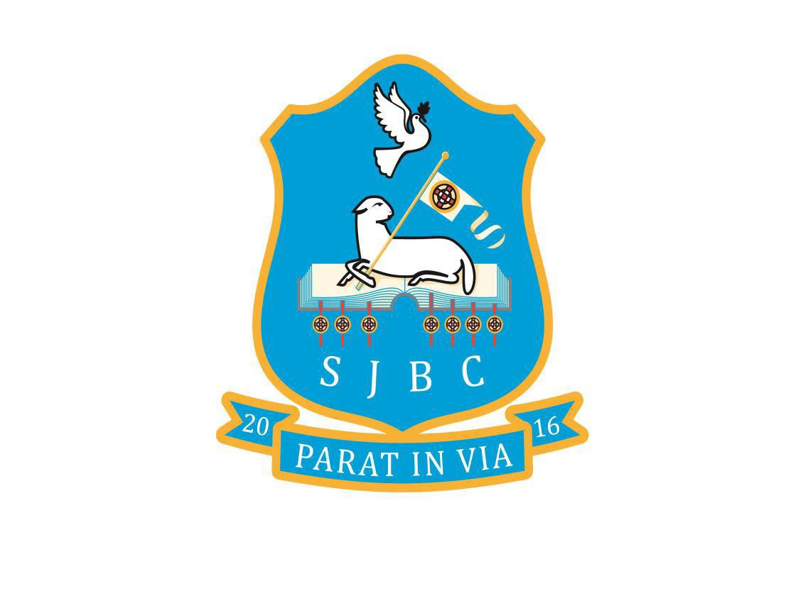

ST. JOHN THE
BAPTIST’S COLLEGE
RELATIONSHIP AND SEXUALITY EDUCATION POLICY
Review Date: Sept 2021
Date of next review: Sept 2022
Prepared by: B Leathem DT
Committee: SLT

ST JOHN THE BAPTIST’S COLLEGE PORTADOWN

Relationship and Sexuality Education Policy Draft

Legal framework for Relationships and Sexuality Education (RSE)

The Education (minimum content) Order (NI) 2007 supports the 2006 Order which requires all grant aided schools to offer a curriculum which:

- Promotes the spiritual, emotional, moral, cultural, intellectual and physical development of pupils at the school and thereby of society; and
- Prepares such pupils for the opportunities, responsibilities and experiences of life by equipping them with the appropriate knowledge, understanding and skills.

From September 2007 a revised school curriculum introduced personal development and mutual understanding (PDMU) in primary schools, which develops into Learning for Life and Work (LLW) in post-primary schools.

Relationships Education is a statutory element of the Northern Ireland Curriculum through Learning for Life and Work. It supports the curriculum aim which is to ‘to empower young people to achieve their potential and to make informed and responsible decisions throughout their lives.’

DE Circular 2015/22 has provided a template for RSE policy documents, and advises on how schools should interact with pupils, focusing on the need to make the pupils feel safe when discussing RSE issues, especially from the fear of being bullied due to their opinions or sexual orientation.

Definition
Relationships and Sexuality Education (RSE) is a lifelong process which encompasses the acquisition of knowledge, understanding and skills, and the development of attitudes, beliefs and values about personal and social relationships and gender issues.

Aims
The aims of RSE are:
- To provide positive, purposeful, safe and structured opportunities for our pupils to acquire a knowledge and understanding of human relationships and sexuality.
- To explore issues around relationships and gender which will enable them to form values and establish behaviour within a moral, spiritual and social framework.
- To encourage pupils to examine and explore the various relationships in their lives and learn how to develop and enjoy friendships which are based on responsibility and mutual respect.
- To provide pupils with the information and skills to evaluate critically the wide range of information, opinions, attitudes and values offered today.
- To encourage pupils to avoid behaviours which could be harmful to themselves and/or others.

Morals and Values Framework
Mindful of the Catholic principles on which the College was founded, and the diverse cultural groups in the school, pupils are taught RSE within a framework that encourages the following:

- a respect for self; a respect for others;
- freedom from bullying due to sexual orientation;
- non-exploitation in relationships;
- commitment, trust and bonding within relationships;
- an exploration of the rights, duties and responsibilities involved in relationships;
- honesty with self and others;
- a development of critical self-awareness for themselves and others;
- an acknowledgement and understanding of diversity regarding religion, culture and sexual orientation.

Inclusion
RSE should:
- be relevant, accessible and age appropriate to all young people;
- be set in a moral framework which is inclusive with respect to culture, religion, sexual orientation and social background;
- seek to develop and clarify values and attitude towards sex, sexuality and relationships and to encourage respect for and empathy with the values and attitudes of other;
- respect the diversity of cultural identity and encourage pupils to be aware of the traditions and beliefs of others, promoting respect, mutual understand and tolerance;
- include activities to allow both genders to talk about their interests, attitudes, emotions, concerns and feelings;
- explore sexual orientation and stereotyping from a range of perspectives.

Confidentiality
- The classroom is an open environment and confidentiality cannot be maintained. Therefore, staff and pupils are not encouraged to talk about their personal relationships or experiences during class discussions.
- Teachers do not promise confidentiality.
- Teachers can provide all pupils with information about where and from whom, they can receive confidential advice and support and to liaise closely with the school Learning Mentor or Counsellor.
- Teachers encourage young people, where possible, to discuss their concerns with parents or guardians.
- In line with the College’s Safeguarding and Child Protection Policy, teachers inform the Designated Teacher for Child Protection of any disclosures which might suggest that a pupil is at risk.

The Role of the Teacher
- When appropriate, teachers provide general RSE advice to all pupils as part of the curriculum. This general advice can be given to pupils individually or within group situations.
- Teachers can provide all pupils with information about where, and from whom, they can receive confidential advice and support.
- Only appropriate medical professionals should give medical advice to pupils.
- Any disclosures that might suggest a pupil is at risk are reported as outlined in the Safeguarding and Child Protection Policy.

Ground Rules for RSE
- It is important to remember that all pupils have a right to age appropriate, accurate and objective information no matter how sensitive the issue is.
- There will be occasions when teachers will be required to exercise discretion in dealing with particularly explicit issues raised by individual pupils. It is not normally appropriate to deal with such issues with the whole class.
- It may be appropriate to discuss the pupil’s concerns with the Pastoral staff/Learning Mentor alongside the parents, and if necessary, individually with the pupil.
- No one (pupil or teacher) is allowed to ask or is expected to answer any personal questions.
- No-one is forced to take part in a discussion. (Participants have the ‘right to pass.’)
- The use of proper terms for parts of the body and body functions is encouraged so that these terms are given a status and respectability.
- Everyone’s contribution will be valued and respected.

The Use of External Agencies
When visiting speakers and external agencies are used in RSE, the College checks the aims, objectives, lesson plans and resources to ensure they are appropriate and support the ethos of the College. Visitors are referred to our website for a copy of our Safeguarding and Child Protection Policy and the Values and Aims Statement. They are asked to adhere to them. The College ensures that visitors are clear about the limits of confidentiality and that the Designated Teacher must be informed of any disclosures which might suggest that a pupil is at risk or that child abuse is suspected.

Parents/guardians are informed via the Parent App when an outside agency is being used. A teacher is present when a visitor is taking a class.

RSE Programme
Our current RSE is covered through:
- Curriculum subjects
- Learning for Life and Work classes
- Workshops
- Assemblies

The objectives and skills of the RSE are also reinforced by the positive climate and constructive everyday interactions between pupils and staff, both inside and outside the classroom.

At Key Stage 3, pupils have opportunities to:
- explore the qualities of relationships including friendship;
- explore the qualities of a loving, respectful friendship;
- develop coping strategies to deal with challenging relationship scenarios;
- develop strategies to avoid and resolve conflict;
- explore the implications of sexual maturation;
- explore the emotional, social and moral implications of early sexual activity.

At Key Stage 4, three of the skills that pupils develop are:
- recognising, assessing and managing risk in a range of real-life contexts;
- developing their understanding of relationships and sexuality and the responsibilities of healthy relationships;
- an understanding of the roles and responsibilities of parenting.

RSE AT KS3 AND KS4 in the Curriculum
- Many of the objectives and skills of RSE, such as decision making, problem solving and working with others, are part of every subject and so all staff contribute, directly or indirectly, to RSE.

- Issues are presented in a way which is free from sensationalism and bias, and sensitively pitched to the pupils’ needs and situations. Pupils are provided with a balanced and non-judgmental view which respects a range of religious and cultural beliefs and also the differing experiences and circumstances of our pupils.

- Science, which is compulsory for all Key Stage 3 and 4 pupils, offers opportunities to address many aspects of RSE. Topics include: the physical changes occurring at puberty, the biology of reproduction, the need to stay healthy during pregnancy, contraception, sexually transmitted infections and interpersonal relationships. Although the emphasis is on factual, biological issues, pupils are encouraged to develop a responsible attitude to sexual behaviour.

- English provides opportunities for pupils to explore and reflect on the various attitudes, values, beliefs and opinions which relate to themselves, their development, their relationships with others and family life. In addition, pupils can develop the use of appropriate vocabulary in different situations and practise communication skills.

- Home Economics provides opportunities for pupils to consider the contribution of positive family relationships to the personal and social development of family members. It covers approach to dealing with home and family issues which analyses viewpoints, considers the factors influencing decisions and the consequences of actions.

- The Religious Education curriculum addresses many aspects of the RSE Programme. It provides opportunities for pupils to consider moral issues, relate moral principles to their personal, social and family life, and identify and explore values and attitudes that influence behaviour. Pupils undertake a range of activities which promote self-respect and respect for others. They have opportunities to consider moral principles in relation to friendship, sexuality, preparation for marriage, single life and parenting based on Christian and other major world religions.

- In Physical Education, the emphasis on enjoyment of, and positive attitudes towards, physical activity is significant in fostering self-esteem and confidence as well as developing a sense of fair play, sharing and co-operation.

- Art and Design afford pupils the experience of individual expression and non-verbal communication.

- Drama Personal and social skills are developed through drama by giving pupils opportunities for the role play of feelings and situations.
- The Personal Development Programme provide opportunities for pupils to explore a range of issues, including: individuality, self-respect and respect for others, peer pressure and media influences, values and attitudes about sexuality and personal implications. Pupils are helped to make informed and responsible decisions about relationships and sexuality.

The RSE provision is monitored and reviewed by the ST Care and Welfare and the ST Curriculum

PARENTS/GUARDIANS
- The College recognises that parents/guardians have a major influence on all aspects of a young person’s life, especially in the area of relationships and sexuality. The College endeavours to help support parents/guardians in this role.
- The RSE programme is accessible to pupil regardless of age, culture, disability, religion, sexual orientation or social background. It is tailored to the pupils’ needs in terms of content, methodology and the resources used.
- There is no statutory parental right to withdraw a child from RSE. The College, however, tries to take account of any parental concerns. It will, as far as possible, make alternative arrangements for any pupil whose parent/guardian requests exemption from specific RSE activities.
- Where issues of a sensitive nature arise teachers encourage pupils to discuss these with their parents/guardians.

REVIEW OF THE RSE POLICY
The College’s policy and RSE programme are informed by the Mission Statement of St John the Baptist’s College, advice from the Department of Education (DfEE), e.g. DfEE Circular Nos. 5/1994, 15/2001 and DE Circular 2015/22, The Education (Northern Ireland) Order 2006 and CCEA’s Guidance for Post Primary Schools, and they are drawn up in consultation with pupils, parents and staff. It is reviewed every three years or more frequently if necessary.

Questions about the policy and programme are initially referred to the Principal or Senior Teacher (Care and Welfare)

Chair of the Board of Governors Date:

