INFORMATION FOR PARENTS
The procedure to follow as a parent if you have a potential child protection concern:

Pastoral Care
ISSUED SEPTEMBER 2021

The happiness of your child is a priority in St John the Baptist’s College. It is important for children to feel secure in the classroom and around school. The school seeks to develop close links with parents and high priority is given to the care and welfare of our pupils.

I can talk to the class/form teacher
I have a concern about my
child’s safety

Pastoral Care involves all pupils and adults within our school and it is our aim to provide a caring and warm environment so that each person involved in school life feels safe and secure.
If I am still concerned, I can talk to the Designated Teacher for child protection – Mrs Brenda Leathem
Deputy Designated Teacher for child protection Mr Justin Lynch or the Principal – Mrs Noella Murray

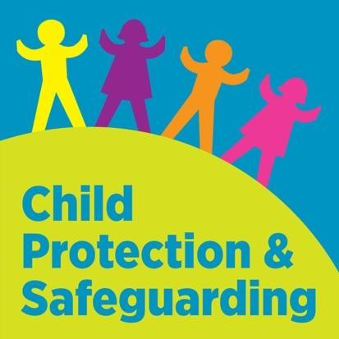
The pastoral care of our pupils means responding to their needs at a period of their young lives when they are developing physically, emotionally and acquiring a wide range of knowledge and skills.
If I am still concerned, I can talk/write to the Nurture Coordinator – Mrs Lynne Swain

School policy statements which contribute to pastoral care:
- Safeguarding and Child Protection
- Behaviour for learning policy
If I am still concerned I can contact the
NI Public Services Ombudsman Tel: 0800 343 424
- Anti-Bullying
- Intimate Care
- Special Educational Needs

St John the Baptist’s College
4 Moy Road
Portadown
CO ARMAGH
BT62 1QQ
TEL: 028 3833 4725
https://www.stjohnthebaptistcollege.co.uk/
- Educational Visits / Risk Assessments
- Health and Safety
At any time, I can talk to the local Children’s Services Gateway Team at 028 37415285 or the PSNI Central
Referral Unit at 028 9025 9299 or 101
- E-Safety
- First Aid /Administration of Medicines
- Relationships and Sexuality Education
- Attendance
- Safe Handling

Child abuse can take any of the following forms:
- Physical
- Emotional
- Neglect
- Sexual
- Exploitation

In cases of suspected abuse, the school will inform Social Services, Education Authority and CCMS.

It is NOT the responsibility of the school to investigate suspected abuse. Parents should be aware that where there is suspected abuse, the welfare of the child is paramount. In the interest of the child, staff may need to share information with other professionals. However, we will ensure that a proper balance between protecting the rights of the child and respecting the rights and needs of families is maintained. Information will be shared only with those who need to know.

We recognise that very young children and those with Special Needs or disabilities have equal rights to protection. Adults in school, charged with their care, follow the school’s Intimate Care Policy and procedures. Copies of this policy and of our Child Protection Policy are available on request.

Copies of these policies are available through our website and via links shared with all parents/guardians through the Parent App.

Child Abuse
Child Protection
Aims and Information

A Child Protection Policy is in operation at St John the Baptist’s College. The aim is to protect our pupils by ensuring that everyone who works in our school – teachers, non-teaching staff and volunteers – has clear guidance on the direction and interagency management of situations where abuse or neglect of a child is suspected. The over-riding concern of all our staff must be the care, welfare and safety of the child.
All staff at St John the Baptist’s College are involved in the development and delivery of our Pastoral Care programme, which includes:
- Providing a range of experiences to support our pupils’ personal, social and emotional development.
- Teaching our children specific strategies to keep themselves safe from harm.
- Involving our children in daily ‘healthy
living’ practices which we hope will influence their whole lives
- Teaching our children about bullying - its meaning and its consequences and how to deal with bullies.

SAFEGUARDING TEAM

Designated Teacher
Mrs B Leathem
Deputy Designated Teacher
Mrs L Swain
Deputy Designated Teacher
Mr J Lynch
The principal concern of all the adults in our school is the care, welfare and safety of our pupils. This is reflected in the aims of our Child Protection Policy:
- To put in place appropriate background checks on all staff and volunteers.
- To ensure that everyone who works in our school knows how to identify signs of abuse and has clear guidance on the action which is required where abuse or neglect of a child is suspected.
- To work together with all agencies concerned with the protection of children.
- To help our pupils learn about the risks of possible abuse,
- To recognise unwelcome behaviour in others and to acquire the confidence and skills to keep themselves safe.

Deputy Principal
Designated Mrs N Murray
Teacher
Mrs C O’Neill

